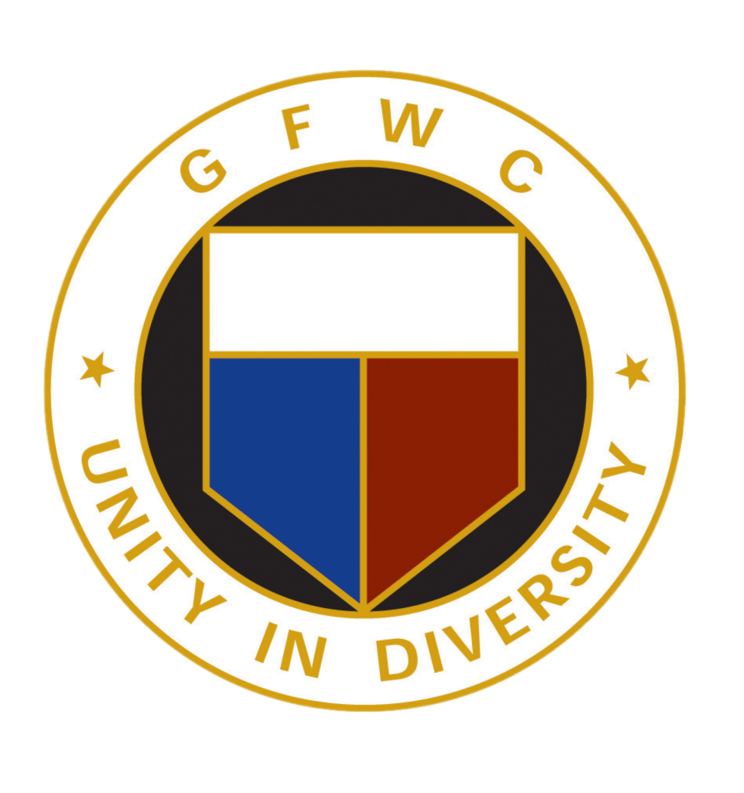
Contact Information:
[Your GFWC Chapter]
[Your Name]
[Your Phone Number]
[Your Email]

PRESS RELEASE

FOR IMMEDIATE RELEASE
[Today’s Date]

SECURE THE CALL AND THE GFWC LAUNCH CELLPHONE DRIVE FOR OCTOBER’S NATIONAL DOMESTIC VIOLENCE AWARENESS MONTH

Takoma Park, FL - The General Federation of Women’s Clubs (GFWC) and Secure the Call (STC) are announcing an October to February cell phone and tablet drive to collect used and unwanted devices for STC’s program to provide free 911 emergency phones and tablets to Domestic Shelters and Police Departments Victim Services that assist with at-risk women.

This program saved the life of a woman not too long ago. According to Kate Smith of the Bluffton Police Department, “She was home alone in her house when her boyfriend, preparing to attack her, cut through her phone line to isolate her. He had trashed her cell phone the month before. Fortunately, she had obtained one of Secure the Call’s 9-1-1 phones the previous week. She called, and the police quickly arrived, most likely saving her life.

Says Mike Morgan, President of Secure the Call, “Our goal is to collect 10,000 phones from now until the end of the year, which will provide our program with the free 911 phones we’ll need for the next 12 months. We’re excited to partner with the GFWC to help us make our numbers. They’re a great organization with 2,000 local chapters around the USA.

The General Federation of Women’s Clubs is an international women’s organization dedicated to community improvement by enhancing the lives of others through volunteer service. GFWC will be collecting phones throughout the month of October and beyond in honor of National Domestic Violence Awareness Month.

All cell phones and tablets will be accepted into their program, with or without the original accessories. Please bring device donations to our drop box at [Donation bin location]

For more information, please contact Secure the Call at (301) 891-2900 or visit them on the web at www.securethecall.org
###

